Task 1: Noise Modelling using Kraus Operators

Noise Modelling using Kraus Operators
In an ideal quantum system, the evolution of a qubit is completely described by the Schrödinger equation. However, real quantum computers are never ideal. The qubit constantly interacts with its surrounding environment, introducing noise into the system. Due to this noise, the qubit can lose energy, lose coherence, or both. Since the Schrödinger equation only describes ideal evolution, we need another way to model these noisy processes. This is done using quantum channels.

Quantum Channels
A quantum channel tells us how the state of a qubit changes when it interacts with the environment. Unlike the Schrödinger equation, which only describes ideal evolution, quantum channels also include the effect of noise.
Every valid quantum channel must satisfy three important properties.
• Completely Positive (CP): Even if our qubit is entangled with another system, the evolution should still produce a physically valid density matrix.
• Trace Preserving (TP): The total probability should always remain equal to one. In other words, Tr(ρ) = 1 must remain true before and after the noisy evolution.
• Linear: If two density matrices are combined linearly, their evolution should also remain linear.
Since every valid quantum channel satisfies these properties, they are called Completely Positive Trace Preserving (CPTP) maps.

Kraus Representation
One way of representing a quantum channel is by using Kraus operators.
ρ' = Σ Ki ρ Ki†
Here,
• ρ is the initial density matrix.
• ρ' is the density matrix after the noisy process.
• Ki are called the Kraus operators.
Each Kraus operator represents one possible way in which the environment can affect the qubit. Since the environment can interact with the qubit in different ways, we generally need more than one Kraus operator to describe a noisy process.
Different noisy processes have different Kraus operators. For example, the Kraus operators for amplitude damping are different from those for pure dephasing.
The Kraus operators must satisfy the completeness condition
Σ Ki†Ki = I
This condition ensures that the trace of the density matrix remains equal to one after the evolution. In other words, the total probability is always conserved.

Kraus Operators for Amplitude Damping
For amplitude damping, the Kraus operators are
K0 = [[1, 0],
[0, √(1-p)]]
K1 = [[0, √p],
[0, 0]]
where p is the probability of relaxation during one time step.
Here, K0 represents the case where no relaxation takes place during the time interval, while K1 represents the relaxation of the excited state |1⟩ to the ground state |0⟩.
The density matrix after amplitude damping is obtained as
ρ' = K0ρK0† + K1ρK1†

Kraus Operators for Pure Dephasing
Similarly, for pure dephasing, the Kraus operators are
K0 = √(1-p/) I
K1 = √(p/) σz
Again, K0 represents the case where no phase error occurs, while K1 represents a phase flip due to the interaction with the environment.
The density matrix after pure dephasing is given by
ρ' = K0ρK0† + K1ρK1†
Unlike amplitude damping, pure dephasing does not change the populations of the basis states. It only reduces the coherence of the qubit.

Evolution over Time
The Kraus operators defined above describe the evolution of the qubit only over a small time interval Δt.
Suppose we want to study the evolution of the qubit for a total time T. Instead of applying the channel once, we divide the total time into small intervals of Δt.
Therefore,
N = T / Δt
Now, during every interval Δt, we first apply the amplitude damping channel and then apply the pure dephasing channel. This gives the state of the qubit after one small time step.
The same process is repeated N times until the total evolution time T is reached. After every iteration, we extract the density matrix, Bloch vector components, state populations and coherence to study how the qubit evolves with time.

Code Implementation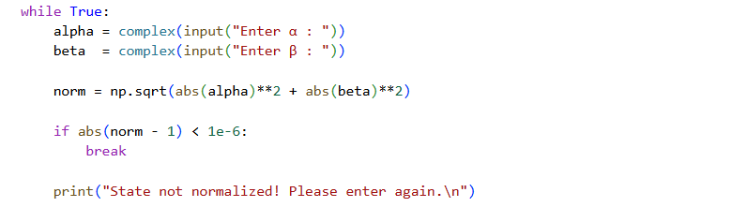
First, I take the initial quantum state as input from the user by asking for the amplitudes α and β. Since a valid quantum state must satisfy the normalization condition |α|² + |β|² = 1, the program first checks whether the entered state is normalized. If it is not, the user is asked to enter the state again. This ensures that only valid quantum states are used in the simulation. 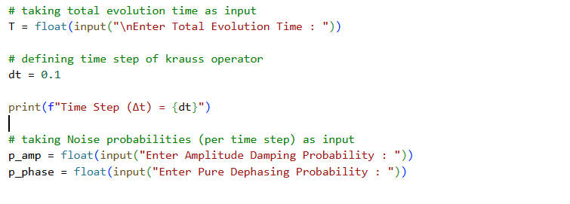
Next, I take the total evolution time T as input from the user. I also define a small time step Δt, which represents one application of the Kraus operators. The evolution is carried out in discrete time steps, so the total number of iterations is calculated as N = T/Δt.
I then take the amplitude damping probability and the pure dephasing probability as input from the user. These probabilities determine the strength of the two noise processes during each time step.
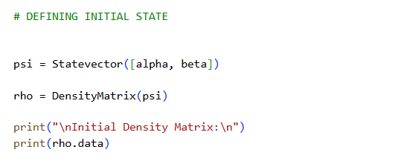
Next, I define the initial quantum state using the Statevector class and convert it into a density matrix using the DensityMatrix class. Since Kraus operators act on density matrices, the simulation is carried out using the density matrix representation of the qubit. 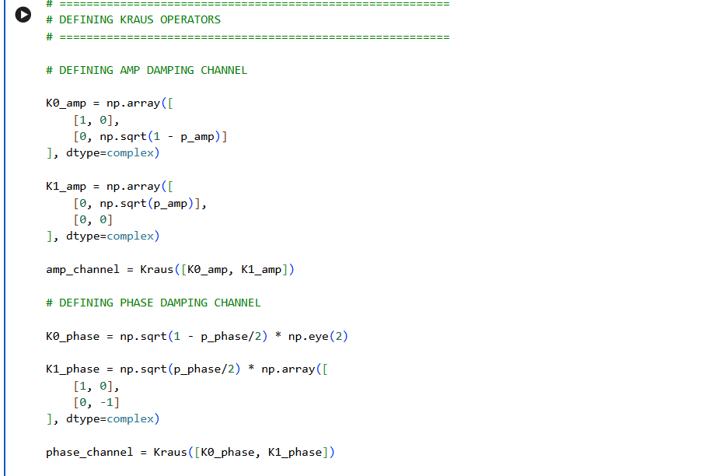
I then define the Kraus operators for amplitude damping and pure dephasing using the probabilities entered by the user. These Kraus operators are grouped together using the Kraus class to form the corresponding quantum channels. 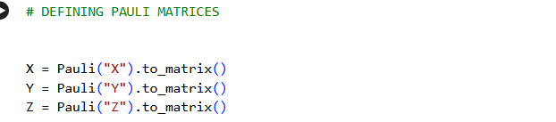
Next, I define the Pauli matrices X, Y and Z. These are later used to calculate the Bloch vector components of the qubit. 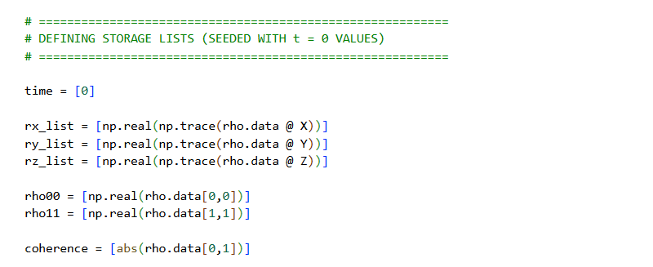
After that, I define separate lists to store the Bloch vector components (rx, ry and rz), the ground-state and excited-state populations (ρ00 and ρ11), the coherence |ρ01| and the corresponding time values.
Before starting the evolution, I store all these quantities at t = 0 so that the plots begin from the initial state of the qubit. 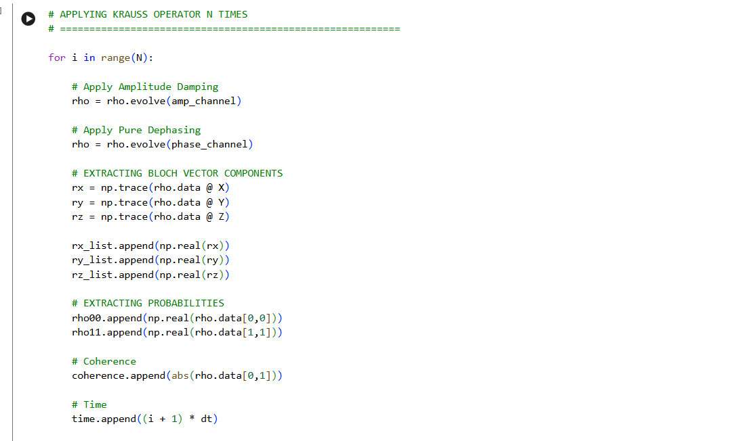
Next, I run a loop for N iterations. During each iteration, I first apply the amplitude damping channel using the evolve() function and then apply the pure dephasing channel to the updated density matrix. This simulates the combined effect of both noise processes during each time step.
After updating the density matrix, I calculate the Bloch vector components using r = Tr(ρσ) for the X, Y and Z Pauli matrices and append these values to their respective lists.
I also extract the diagonal elements of the density matrix, ρ00 and ρ11, which represent the probabilities of finding the qubit in the ground and excited states, respectively. The magnitude of the off-diagonal element |ρ01| is also calculated and stored since it represents the coherence of the qubit. Finally, I store the corresponding time value.
After the simulation is complete, I print the final density matrix and the final Bloch vector components to observe the final state of the qubit after evolving under the effect of both amplitude damping and pure dephasing.
Finally, I generate three plots. The first plot shows the evolution of the Bloch vector components with time. The second plot shows how the ground-state and excited-state populations change due to amplitude damping. The third plot shows the decay of the coherence |ρ01| with time, illustrating how the combined effect of amplitude damping and pure dephasing gradually destroys the coherence of the qubit.

